|  |  |  |
| --- | --- | --- |
|  |  |  |
| E-12446-01-01\_RS\_01 |  | Rel Date |
| Description: E:\New Mysore 2013 Oct\TS Transformation\lnt ts_logo.jpg | | |
| **LTTS\_Develop\_Social\_Influencer(Web + Mobile Application)** | | |
| **Requirements Specification** | | |
|  | | |
|  | | |
|  |  |  |
|  | Ver – 1.0 |  |
|  |  |  |
|  |  | EMB\_RM\_01F/8.2/17-Apr-18 |
|  |  |  |

**DOCUMENT HISTORY**

|  |  |  |  |  |  |
| --- | --- | --- | --- | --- | --- |
| **Ver. Rel. No** | **Release Date** | **Mod.By**  **Mod. Dt** | **Rev. By**  **Relevant Stakeholders**  **Rev. Dt.** | **Auth By**  **Auth Dt.** | **Remarks/ Revision details** |
| 1.0 | 03-Apr-2020 | Chetha G C | Raghavendra | Raghavendra |  |
| 18-Nov-2020 | 05-Apr-2020 | 05-Apr-2020 |
|  |  |  |  |  |  |
|  |  |  |

**Table of contents**

[**1.0**](#_heading=h.30j0zll) **Introduction 4**

[1.1](#_heading=h.1fob9te) Purpose of this project 4

[1.2](#_heading=h.3znysh7) Key success Factors 4

[1.3](#_heading=h.2et92p0) Stakeholders Reference 4

[1.4](#_heading=h.3dy6vkm) References 4

[**2.0**](#_heading=h.1t3h5sf) **Project Descriptions 4**

[2.1](#_heading=h.4d34og8) Product / Project Overview 4

[2.2](#_heading=h.2s8eyo1) Block Diagram 4

[2.3](#_heading=h.17dp8vu) Scope of the Project 5

[2.4](#_heading=h.3rdcrjn) Not in the scope of the Project 6

[2.5](#_heading=h.lnxbz9) Product Functions / General Descriptions 6

[2.6](#_heading=h.35nkun2) Annual quantity/ prototype quantity 6

[2.7](#_heading=h.1ksv4uv) Expected product life 6

[2.8](#_heading=h.44sinio) Similar System Information 6

[2.9](#_heading=h.2jxsxqh) System Environment 7

[2.10](#_heading=h.3j2qqm3) Tools / Software /components agreed to be supplied by the customer 7

[2.11](#_heading=h.1y810tw) Design and Implementation Constraints 7

[*•*](#_heading=h.4i7ojhp) *Constraints from Test System Perspective (TBD) 7*

[*•*](#_heading=h.2xcytpi) *Constraints from Android Perspective (TBD) 7*

[*•*](#_heading=h.1ci93xb) *Constraints from Modem Framework Perspective (TBD) 7*

[2.12](#_heading=h.3whwml4) Assumptions and Dependencies 7

[2.13](#_heading=h.2bn6wsx) Customer Requirements on Retention period & “Hazard Analysis” 7

[**3.0**](#_heading=h.qsh70q) **Application Environment 8**

[3.1](#_heading=h.3as4poj) Business Context 8

[*3.1.1*](#_heading=h.1pxezwc) *Environment 8*

[*3.1.2*](#_heading=h.49x2ik5) *Functions 8*

[*3.1.3*](#_heading=h.2p2csry) *Problems / Risks to be watched for 8*

[3.2](#_heading=h.147n2zr) Operational Concepts & Scenarios: 8

[*Android test application to work as a client. Testing is driven from server (test system). All the commands sent from Test Application should be honoured. 8*](#_heading=h.3o7alnk)

[3.3](#_heading=h.23ckvvd) User Profiles 8

[3.4](#_heading=h.ihv636) Cost 8

[**4.0**](#_heading=h.32hioqz) **Details of requirements gathering process 8**

[4.1](#_heading=h.1hmsyys) Strategy / Process adopted for Requirements Gathering and Elicitation 8

[**5.0**](#_heading=h.41mghml) **Requirements Specifications 9**

[5.1](#_heading=h.2grqrue) System Requirements 9

[5.2](#_heading=h.vx1227) Software Requirements 9

[*Launching Android test application in the background (without UI). It should launch with device power ON. 9*](#_heading=h.3fwokq0)

[*NA 9*](#_heading=h.1v1yuxt)

[*Test application should launch with or without configuration file 9*](#_heading=h.4f1mdlm)

[*SWR\_01 10*](#_heading=h.2u6wntf)

[*Uninstall and reinstall the application. Application should also run in daemon process in the next power cycle 10*](#_heading=h.19c6y18)

[*SWR\_01 10*](#_heading=h.3tbugp1)

[*After launching Test App should establish and listen to two Internet Protocol (IP) sockets. 10*](#_heading=h.28h4qwu)

[*SWR\_02 10*](#_heading=h.nmf14n)

[*Verify application can communicate through Wi-Fi AP 11*](#_heading=h.37m2jsg)

[*SWR\_04 11*](#_heading=h.1mrcu09)

[*Verify application can communicate through USB 11*](#_heading=h.46r0co2)

[*SWR\_04 12*](#_heading=h.2lwamvv)

[*Once the Test App is launched it should able to receive all types of commands with various parameters(JSON format) 12*](#_heading=h.111kx3o)

[*SWR\_03 12*](#_heading=h.3l18frh)

[*Once the Test App is launched it should able to reply to all types of commands with various parameters(JSON format) 12*](#_heading=h.206ipza)

[*SWR\_07 13*](#_heading=h.4k668n3)

[*SWR\_08 13*](#_heading=h.2zbgiuw)

[*NA 14*](#_heading=h.3ygebqi)

[*NA 14*](#_heading=h.2dlolyb)

[*NA 15*](#_heading=h.sqyw64)

[*NA 15*](#_heading=h.3cqmetx)

[*NA 16*](#_heading=h.1rvwp1q)

[*NA 16*](#_heading=h.4bvk7pj)

[5.3](#_heading=h.2r0uhxc) Hardware Requirements 16

[5.4](#_heading=h.1664s55) Engineering Requirements 16

[5.5](#_heading=h.3q5sasy) Non-Functional Requirements 16

[5.6](#_heading=h.25b2l0r) Operational Requirements (OPR) 17

[5.7](#_heading=h.kgcv8k) Product Standards Requirements (PSDR) 17

[5.8](#_heading=h.34g0dwd) Safety Requirements (SFR) 17

[5.9](#_heading=h.1jlao46) Statutory/Regulatory Requirements (SR) 17

[5.10](#_heading=h.43ky6rz) Mechanical/EMI EMC Requirements (EMI/EMC) 17

[5.11](#_heading=h.2iq8gzs) Security Requirements (SCR) 17

[5.12](#_heading=h.xvir7l) Reliability Requirements- (RLR) 17

[5.13](#_heading=h.3hv69ve) Availability Requirements – (AVR) 17

[5.14](#_heading=h.1x0gk37) Maintainability Requirements – (MTR) 17

[5.15](#_heading=h.4h042r0) Manufacturing Requirements (MFR) 17

[5.16](#_heading=h.2w5ecyt) Installation /Servicing Requirements (ISR) 17

[5.17](#_heading=h.1baon6m) Product Obsolescence (PRO) 17

[5.18](#_heading=h.3vac5uf) Usability Requirements (UR) 17

[5.19](#_heading=h.2afmg28) User training Requirements (UTR) 18

[5.20](#_heading=h.pkwqa1) Sterilization/Cleanliness related Requirements (SCRR) 18

[**6.0**](#_heading=h.1opuj5n) **Implicit Requirements 18**

[**7.0**](#_heading=h.48pi1tg) **Non-Technical Requirements 18**

[7.1](#_heading=h.2nusc19) Deliverables and Acceptance Criteria 18

[**8.0**](#_heading=h.1302m92) **Special Requirement 19**

[**9.0**](#_heading=h.3mzq4wv) **Test Strategy 19**

[**10.0**](#_heading=h.2250f4o) **Glossary 19**

# Introduction

## Purpose of this project

To create a social Influencer Android and Web Application which creates a platform for the advertisers and influencers to promote the products.

## Key success Factors

* Should be able to test all the scenarios defined by the test system
* Best customer/user experience

## Stakeholders Reference

* Chethan G C: [chethan.gc@ltts.com](mailto:chethan.gc@ltts.com)
* Raghavendra CS: [raghavendra.cs@ltts.com](mailto:raghavendra.cs@ltts.com)

## References

1. CES\_SW\_Shadow Project Proposal Ver 1.0 \_Social\_Influncer\_Raghvendra (LTTS)

# Project Descriptions

## Product / Project Overview

* To develop social influencer mobile and web application in which is the provides a platform for both influencer and advertiser for the product promotion. In this platform

## Block Diagram

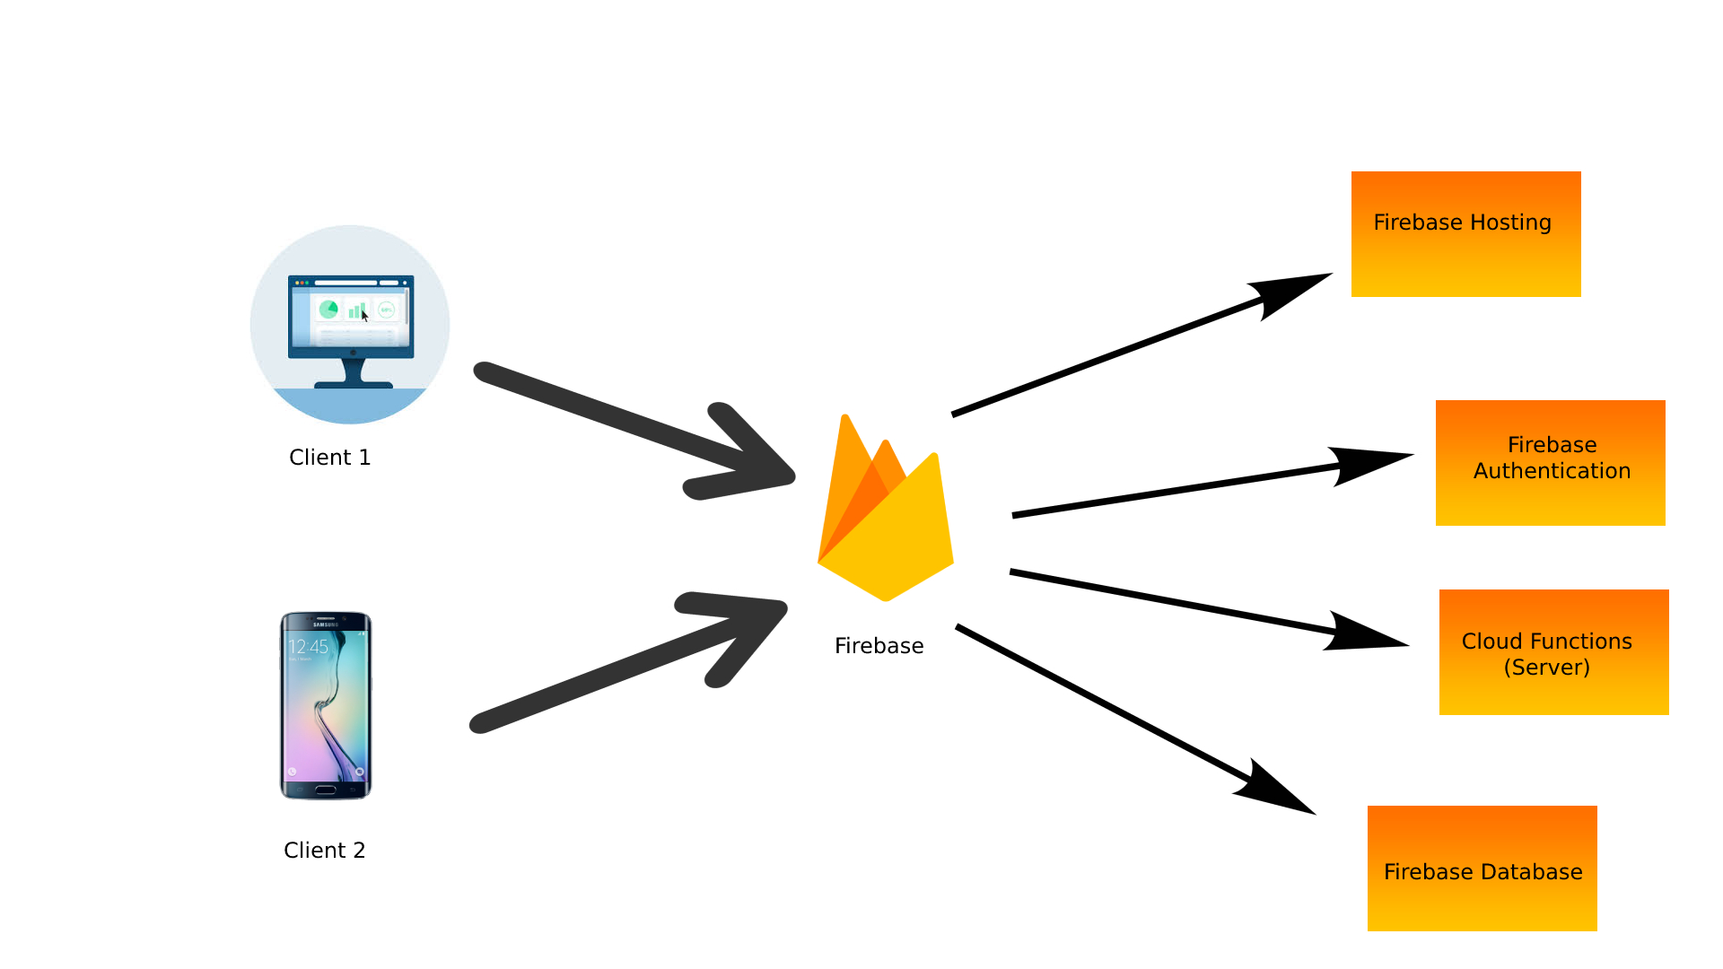

## 

## Scope of the Project

* Creating a platform for the advertisers and the influencers for the product promotion
* The android should contain the user friendly UI.
* Creating Android application for the Influncers
* Creating the web and android application for both web and influencers
* Usage of firebase cloud functions for hosting
* Usage of firebase hosting to host the website

## Not in the scope of the Project

* UI testing
* Wireframe designs for the project
* Firebase authentication

## Product Functions / General Descriptions

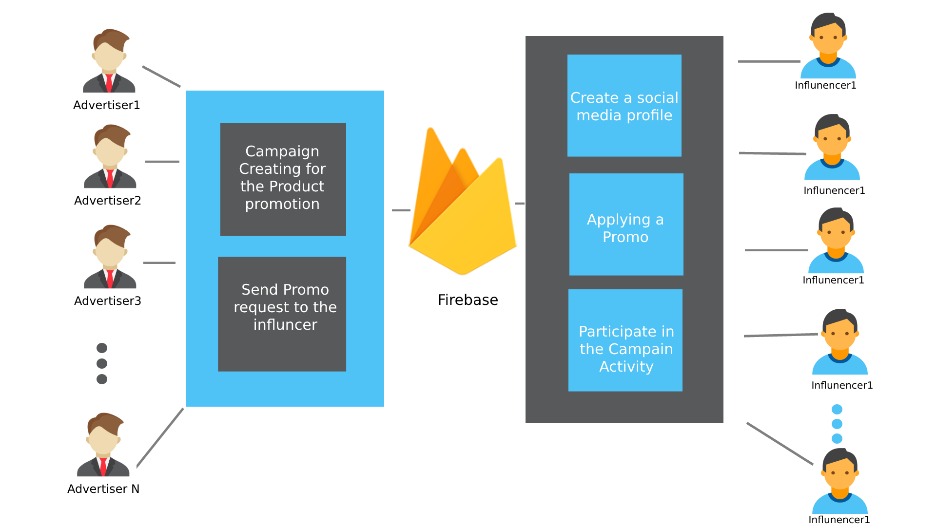

* The product should allow the advertisers to create the product campaigns and send the promo request to the influencers
* The product should allow the influencer to create a profile, apply for the promo and allow them to participate in the campaign activity.
* The product should use the technologies mentioned. ie firebase, Node JS.

## Annual quantity/ prototype quantity

NA

## Expected product life

* The maintenance of the server is done by the google firebase so the customer no need to worry about the maintenance and other things.
* Scalable depending on the customer needs.

## Similar System Information

* There was one similar system available in LTTS, which from the one of big advertisement company which resembles the same requirements

## System Environment

* Emulator
* All Android Phones
* Chrome , Firefox and safari browsers

## Tools / Software /components agreed to be supplied by the customer

|  |
| --- |
| 1. **Wireframe ( Online tools or Android XD) for the web and android.** |
| 1. **Firebase Tools.** |

**2.10.1 Technologies to used:**

|  |
| --- |
| **Firebase Authentications** |
| **Firebase Real time Database** |
| **Firebase Hosting** |
| **Functions in Firebase** |
| **VS code for web.** |
| **Android Studio** |
| **Wireframe ( Online tools or Android XD) for the web and android.** |
| **Node JS 8.** |
| **Express.** |
| **Firebase Tools.** |
| **Postman.** |
| **Javascript.** |
| **CSS 3.** |
| **HTML 5.** |
| **JAVA.** |
| **XML.** |

## Design and Implementation Constraints

### NA

## Assumptions and Dependencies

.

* Social media profiles are created based on assumed data.
* Dependency on firebase.

## Customer Requirements on Retention period & “Hazard Analysis”

**NA**

# Application Environment

## Business Context

### Environment

#### NA

### Functions

NA

### Problems / Risks to be watched for

#### NA

## Operational Concepts & Scenarios:

NA

## User Profiles

NA

## Cost

NA

# Details of requirements gathering process

## Strategy / Process adopted for Requirements Gathering and Elicitation

* Based on the requirement document that was provided during the initial project Kickoff
* Based on the stakeholder requirement elaboration.

# Requirements Specifications

All the requirements are segregated into Technical & Non-Technical requirements. The technical requirements are captured in section 6.0 and the Non-technical requirements are captured in sec 8.0.

The Requirements Specifications have been divided into five categories

1. System Requirements
2. Software Requirements
3. Hardware Requirements
4. Engineering Requirements and
5. Non-Functional Requirements



## System Requirements

* Android Studio
* Firebase
* VS Code
* Photoshop(Wireframe)
* NodeJS 8
* Browser
* Postman
* Emulator (Virtual Android Phone)

An android phone running on android version 5.0 or greater than that is required for running the android application.

A browser that supports the HTML5, CSS3, NodeJS is required for running the application.

## Software Requirements

|  |  |
| --- | --- |
| **Requirement Id.** | SWR\_01 |
| **Reference** | 1. CES\_SW\_Shadow Project Proposal Ver 1.0 \_Social\_Influncer\_Raghvendra   https://drive.google.com/file/d/1xf4PE8vbuwiwdQ8s73jn1DneVsrI2w8s/view?usp=sharing |
| **Description** | Login in the web app (Firebase Authentication) |
| **Criticality** | Critical |
| **Technical issues** | NA |
| **Risks** | NA |
| **Dependencies with other requirements** | NA |
| **Expected Results with acceptability limits, Wherever applicable** | 1. Both advertisers and Influencers should be able to login to the system.  2. Should work on both android and Web Application. |
| **Method of Verification** | Manual verification |
| **Method of Validation** | NA |

|  |  |
| --- | --- |
| **Requirement Id.** | SWR\_02 |
| **Reference** | 1. CES\_SW\_Shadow Project Proposal Ver 1.0 \_Social\_Influncer\_Raghvendra   https://drive.google.com/file/d/1xf4PE8vbuwiwdQ8s73jn1DneVsrI2w8s/view?usp=sharing |
| **Description** | Google Login |
| **Criticality** | Critical |
| **Technical issues** | NA |
| **Risks** | NA |
| **Dependencies with other requirements** | SWR\_01 |
| **Expected Results with acceptability limits, Wherever applicable** | 1. Both advertisers and Influencers should be able to login using their google login.   1. Should work on both android and Web Application. |
| **Method of Verification** | Manual verification |
| **Method of Validation** | NA |

|  |  |
| --- | --- |
| **Requirement Id.** | SWR\_03 |
| **Reference** | 1. CES\_SW\_Shadow Project Proposal Ver 1.0 \_Social\_Influncer\_Raghvendra   https://drive.google.com/file/d/1xf4PE8vbuwiwdQ8s73jn1DneVsrI2w8s/view?usp=sharing |
| **Description** | Register in the application |
| **Criticality** | Critical |
| **Technical issues** | NA |
| **Risks** | NA |
| **Dependencies with other requirements** | SWR\_01 |
| **Expected Results with acceptability limits, Wherever applicable** | 1. Both Advertiser and Influncer should be able to register.  2.Should work on both android and Web Application. |
| **Method of Verification** | Manual verification |
| **Method of Validation** | NA |

|  |  |
| --- | --- |
| **Requirement Id.** | SWR\_04 |
| **Reference** | 1. CES\_SW\_Shadow Project Proposal Ver 1.0 \_Social\_Influncer\_Raghvendra   https://drive.google.com/file/d/1xf4PE8vbuwiwdQ8s73jn1DneVsrI2w8s/view?usp=sharing |
| **Description** | Forgot password |
| **Criticality** | Ctritical |
| **Technical issues** | NA |
| **Risks** | NA |
| **Dependencies with other requirements** | SWR\_01 |
| **Expected Results with acceptability limits, Wherever applicable** | 1. Both Advertiser and Influncer should be able to forget the password.  2.Should work on both android and Web Application. |
| **Method of Verification** | Manual verification |
| **Method of Validation** | NA |

|  |  |
| --- | --- |
| **Requirement Id.** | SWR\_05 |
| **Reference** | 1. CES\_SW\_Shadow Project Proposal Ver 1.0 \_Social\_Influncer\_Raghvendra   https://drive.google.com/file/d/1xf4PE8vbuwiwdQ8s73jn1DneVsrI2w8s/view?usp=sharing |
| **Description** | Social media profile creation |
| **Criticality** | Critical |
| **Technical issues** | NA |
| **Risks** | NA |
| **Dependencies with other requirements** | NA |
| **Expected Results with acceptability limits, Wherever applicable** | 1. Influncer should be able to create their own profiles with the social media links  2.Should work on both android and Web Application. |
| **Method of Verification** | Manual verification |
| **Method of Validation** | NA |

|  |  |
| --- | --- |
| **Requirement Id.** | SWR\_06 |
| **Reference** | 1. CES\_SW\_Shadow Project Proposal Ver 1.0 \_Social\_Influncer\_Raghvendra   https://drive.google.com/file/d/1xf4PE8vbuwiwdQ8s73jn1DneVsrI2w8s/view?usp=sharing |
| **Description** | Dashboard for the Influncer to see the details of campaigns. |
| **Criticality** | Critical |
| **Technical issues** | NA |
| **Risks** | NA |
| **Dependencies with other requirements** | SWR\_05 |
| **Expected Results with acceptability limits, Wherever applicable** | 1. Influncer should be able to see the present running campaigns and past campaigns that he was part of.  2.Should work on both android and Web Application. |
| **Method of Verification** | Manual verification |
| **Method of Validation** | NA |

|  |  |
| --- | --- |
| **Requirement Id.** | SWR\_07 |
| **Reference** | 1. CES\_SW\_Shadow Project Proposal Ver 1.0 \_Social\_Influncer\_Raghvendra   https://drive.google.com/file/d/1xf4PE8vbuwiwdQ8s73jn1DneVsrI2w8s/view?usp=sharing |
| **Description** | Provision for selecting and applying for a promo. |
| **Criticality** | Critical |
| **Technical issues** | NA |
| **Risks** | NA |
| **Dependencies with other requirements** | SWR\_06 |
| **Expected Results with acceptability limits, Wherever applicable** | 1. Influncer should be able to apply for a promo for the running campaign.  2.Should work on both android and Web Application. |
| **Method of Verification** | Manual verification |
| **Method of Validation** | NA |

|  |  |
| --- | --- |
| **Requirement Id.** | SWR\_08 |
| **Reference** | 1. CES\_SW\_Shadow Project Proposal Ver 1.0 \_Social\_Influncer\_Raghvendra   https://drive.google.com/file/d/1xf4PE8vbuwiwdQ8s73jn1DneVsrI2w8s/view?usp=sharing |
| **Description** | Create the promotion campaigns for the web app |
| **Criticality** | Critical |
| **Technical issues** | NA |
| **Risks** | NA |
| **Dependencies with other requirements** | NA |
| **Expected Results with acceptability limits, Wherever applicable** | 1. The promotion Campaign should contain the Name of the product, Description of the product, Image of the product, Pricing for the product promotion campaign, Start and end date of the campaign. |
| **Method of Verification** | Manual verification |
| **Method of Validation** | NA |

|  |  |
| --- | --- |
| **Requirement Id.** | SWR\_09 |
| **Reference** | 1. ICD Document: [https://docs.google.com/document/d/1eCujX-sfJ4aa4Fu2OglcNjT2v-8lHAlFqr723rJMP9A/edit?usp=sharing](https://ind01.safelinks.protection.outlook.com/?url=https%3A%2F%2Fdocs.google.com%2Fdocument%2Fd%2F1eCujX-sfJ4aa4Fu2OglcNjT2v-8lHAlFqr723rJMP9A%2Fedit%3Fusp%3Dsharing&data=02%7C01%7Cpasula.bhargav%40ltts.com%7Cce8d8725779e4376100c08d7da6e3cc7%7C311b33788e8a4b5ea33fe80a3d8ba60a%7C0%7C0%7C637218039328970641&sdata=%2FH20KtinZNSSB8oqBdQ9DxqnJCGavD0wMOMKzdXq2SA%3D&reserved=0) 2. TDD Document- [https://docs.google.com/document/d/1\_-Enilej398UrpOXnqGn2BDzbkzurt3K-iwhkRvR\_SI/edit?usp=sharing](https://ind01.safelinks.protection.outlook.com/?url=https%3A%2F%2Fdocs.google.com%2Fdocument%2Fd%2F1_-Enilej398UrpOXnqGn2BDzbkzurt3K-iwhkRvR_SI%2Fedit%3Fusp%3Dsharing&data=02%7C01%7Cpasula.bhargav%40ltts.com%7Cce8d8725779e4376100c08d7da6e3cc7%7C311b33788e8a4b5ea33fe80a3d8ba60a%7C0%7C0%7C637218039328970641&sdata=LWO6Ay9N2M2q3vQ8N3BF6S5VDNCpU8MxM3hf7GjcIgs%3D&reserved=0) |
| **Description** | Filter and search influencer. |
| **Criticality** | Critical |
| **Technical issues** | NA |
| **Risks** | NA |
| **Dependencies with other requirements** | SWR\_08 |
| **Expected Results with acceptability limits, Wherever applicable** | 1.Global search to search the campaign based on the Campaigning name  2.Searching based on the filters |
| **Method of Verification** | Manual verification |
| **Method of Validation** | NA |

|  |  |
| --- | --- |
| **Requirement Id.** | SWR\_10 |
| **Reference** | 1. CES\_SW\_Shadow Project Proposal Ver 1.0 \_Social\_Influncer\_Raghvendra   https://drive.google.com/file/d/1xf4PE8vbuwiwdQ8s73jn1DneVsrI2w8s/view?usp=sharing |
| **Description** | Provision to send the promo request to Influencers. |
| **Criticality** | Critical |
| **Technical issues** | NA |
| **Risks** | NA |
| **Dependencies with other requirements** | NA |
| **Expected Results with acceptability limits, Wherever applicable** | 1. Advertisers should be able to send the promo request to the influencer by see the influencer profile details. |
| **Method of Verification** | Manual verification. |
| **Method of Validation** | NA |

|  |  |
| --- | --- |
| **Requirement Id.** | SWR\_11 |
| **Reference** | 1. CES\_SW\_Shadow Project Proposal Ver 1.0 \_Social\_Influncer\_Raghvendra   https://drive.google.com/file/d/1xf4PE8vbuwiwdQ8s73jn1DneVsrI2w8s/view?usp=sharing |
| **Description** | Dashboard to see all the running promotion campaigns (Past and Running). |
| **Criticality** | Critical |
| **Technical issues** | NA |
| **Risks** | NA |
| **Dependencies with other requirements** | SWR\_08 |
| **Expected Results with acceptability limits, Wherever applicable** | 1. Adversiters dashboard should contain the past and present campaigns that he is part of. |
| **Method of Verification** | Manual verification |
| **Method of Validation** | NA |

## Hardware Requirements

|  |
| --- |
| Android Mobile |
| Laptop/Desktop with Windows 10. RAM – 8 GB min (16 GB recommended) |

## Engineering Requirements

NA

## Non-Functional Requirements

* Reliability
* Maintenance
* Better User Experience
* Better Throughput
* Better User Interface

## Operational Requirements (OPR)

NA

## Product Standards Requirements (PSDR)

NA

## Safety Requirements (SFR)

NA

## Statutory/Regulatory Requirements (SR)

NA

## Mechanical/EMI EMC Requirements (EMI/EMC)

NA.

## Security Requirements (SCR)

* Usage of the Native application development forms instead of using the 3rd party frameworks.

## Reliability Requirements- (RLR)

* The apps should not crash and show different behaviour to the user
* The apps should be flexible to scale and reuse whenever it is required.

## Availability Requirements – (AVR)

NA

## Maintainability Requirements – (MTR)

NA

## Manufacturing Requirements (MFR)

NA

## Installation /Servicing Requirements (ISR)

NA

## Product Obsolescence (PRO)

NA

## Usability Requirements (UR)

NA

## User training Requirements (UTR)

NA

## Sterilization/Cleanliness related Requirements (SCRR)

NA

# Implicit Requirements

NA

# Non-Technical Requirements

## Deliverables and Acceptance Criteria

* The Android application for the influencers with all the requirements mentioned above
* The web app with all the requirements mentioned above for both influencer and advertisers.

|  |  |  |  |  |  |
| --- | --- | --- | --- | --- | --- |
| **Deliverables agreed**  **(Both Intermediate & Final**) | **Date of Delivery, Only if committed to the customer** | **Deliverable format** | **Acceptance Criteria** | | **Remarks** |
| **Task** | **Responsibility** |
| The android application with all the requirements and testing +bug fixing | 15-Dec-2020 | Android APK, and the respective Documents |  |  |  |
| The Web application with all the requirements and testing +bug fixing | 15-Dec-2020 | Deployed web application, and the respective Documents |  |  |  |

**Other aspects agreed upon:**

1. Periodic Reviews with the stakeholders: Weekly, every day.

Visits to customers place: NA

# Special Requirement

NA

# Test Strategy

##### Testing the android application functions and UI using the JUnit testing

##### Testing the web node application apis using postman

##### Testing the application for the unexpected inputs and wrong inputs

##### Testing Ui of the web application using the selenium IDE.

# Glossary

NA